Logging in and Admin User Names

- Goto the link below
- add your User Name (see below)
- select “forgot password”

https://swimming.canada.sportsmanager.ie/maint.php

Your administrator username for logging in to the REMS system will be:
Registrar, Meet Manager, COA, Treasurer, Head Coach or President
“Role_first name last name club”
3 or 4 letter club code all capitals

Your first name
Your last name

For example: “Registrar_Jane Smith XXXX”

Registering Swimmers & Coaches

- Use the Group Registration Training Guide – Club to guide you through registering each member
- They system only lets you register up to 50 swimmers at a time
- Once you hit 50, you will select the “Next” button and it will automatically generate the invoices for this “batch” of registrants
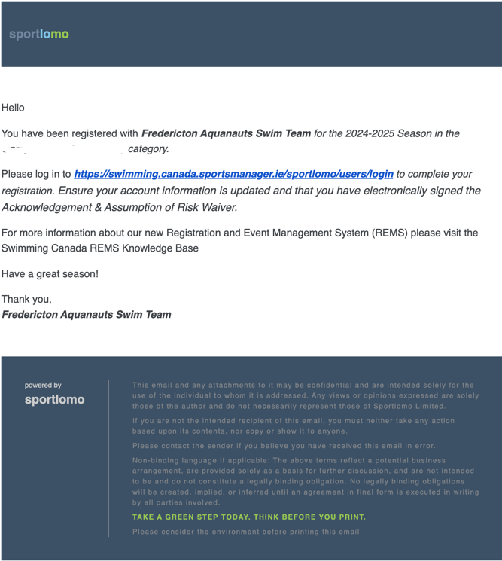
- If you have more swimmers to register, go back to Registration and start the next “batch” until everyone is registered

Your members will automatically receive an email with a login link (see below) once your registered
Give people notice they will get this email and it isn’t spam

Send your members a copy of the Complete Registration Training Guide

Sportlomo has a feature that other sports use where athletes can register directly with their national sport organization through their website. This is NOT how SNC/SNB is using the system. We do not want our members creating their own accounts that is why its important for them to ONLY use the link that they receive via email after you register them to log in to their account.

If they do happen to do this and create a new account, just let us know and we can fix it on our end.

DO NOT USE
Please advise members to wait for a registration confirmation email from sportlomo

Do not use the “Register/Renew” red button

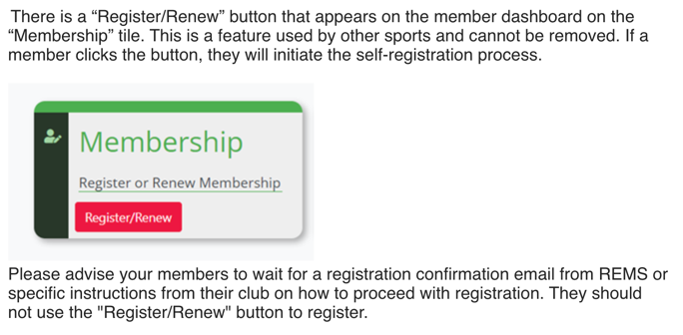

Questions & Support

If you have questions or inquiries, please consult the following recourses in this order:

- SNC Knowledge Base

- Email support@swimming.ca

- Email info@swimnb.ca

- Phone SNB at 506-470-8834, Mon–Fri 8:00 – 5:00 pm

*Note: Swimming Canada is the first point of contact for questions and inquiries. The REMS system is also new to SNB and, like you, we're still learning how to use it. But don't hesitate to contact SNB if you can't get the help you need.

